1. Write a JavaScript program that prints all even numbers from 1 to 20

**Program**: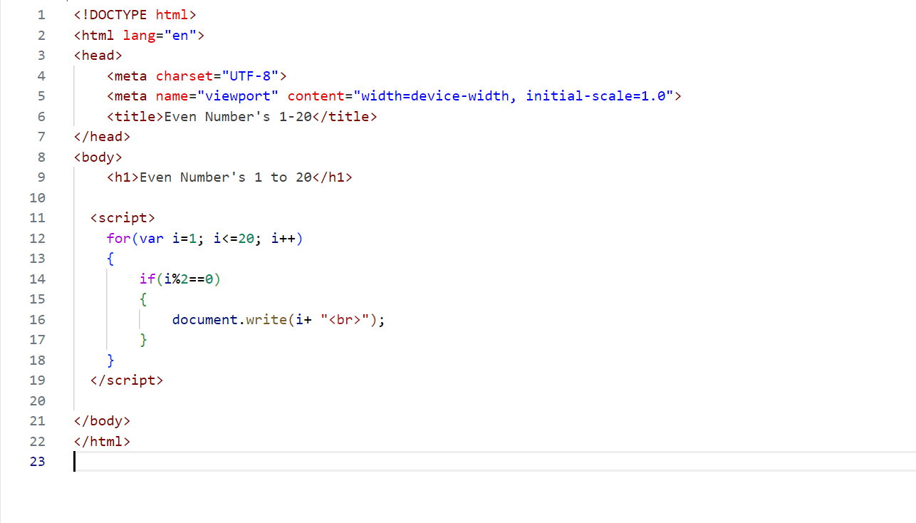**Output:**

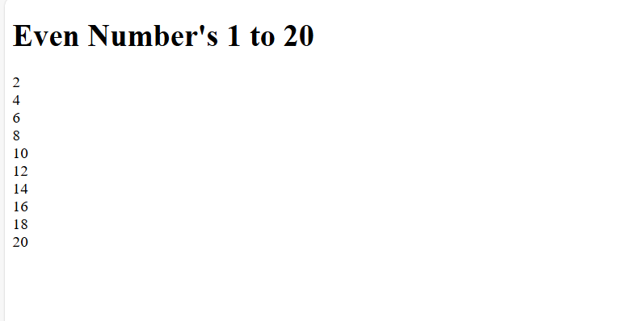

1. Create a JavaScript function that checks if a given number is prime.

**Program:**

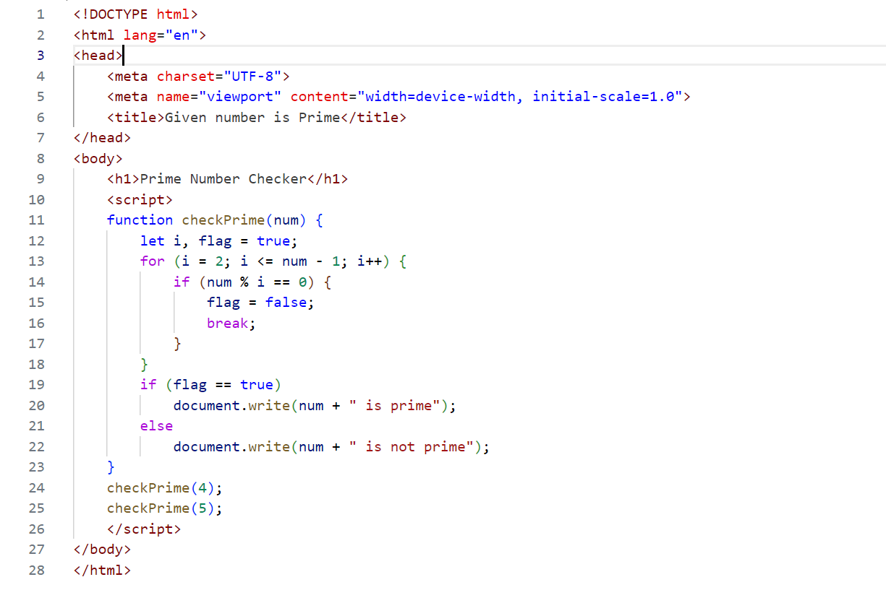

**Output:**

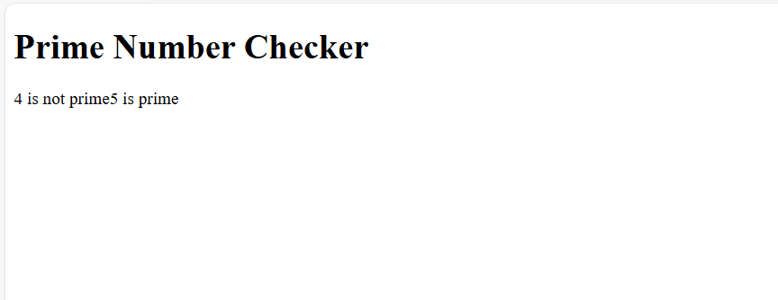

1. Write a JavaScript program to find the largest of three numbers.

**Program:**

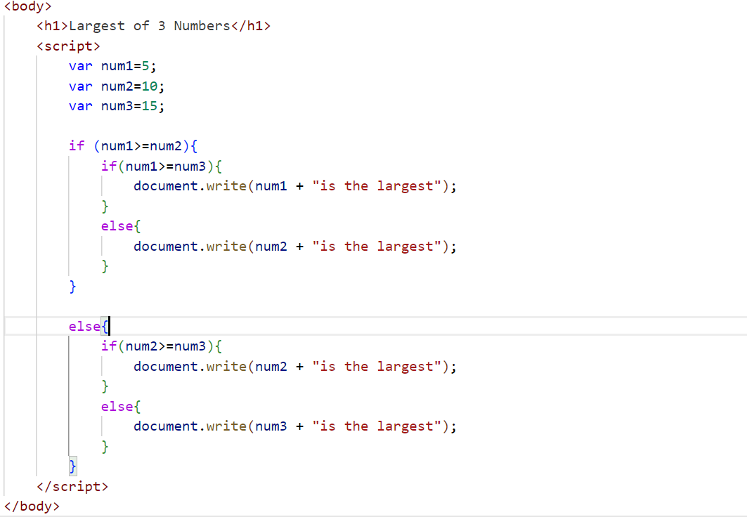

**Output:**

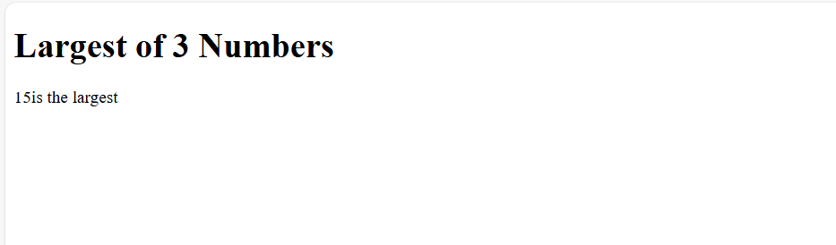

1. Develop a JavaScript function to calculate the factorial of a number using a for loop.

**Program:**

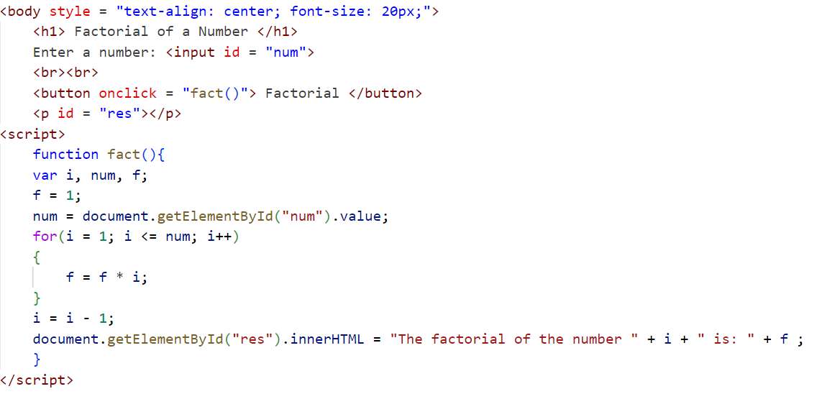

**Output:**

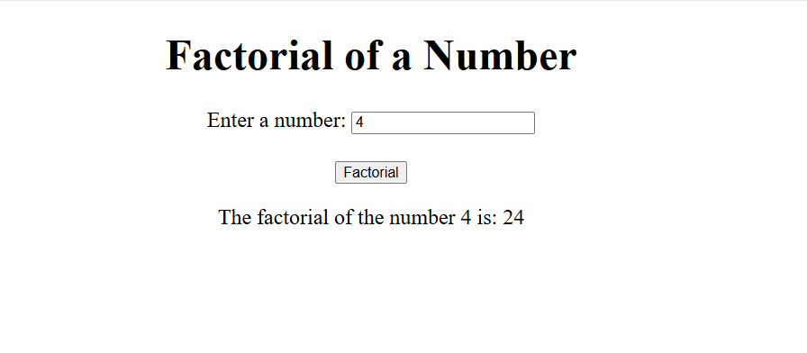

1. Create a JavaScript program that reverses a given string.

**Program:**

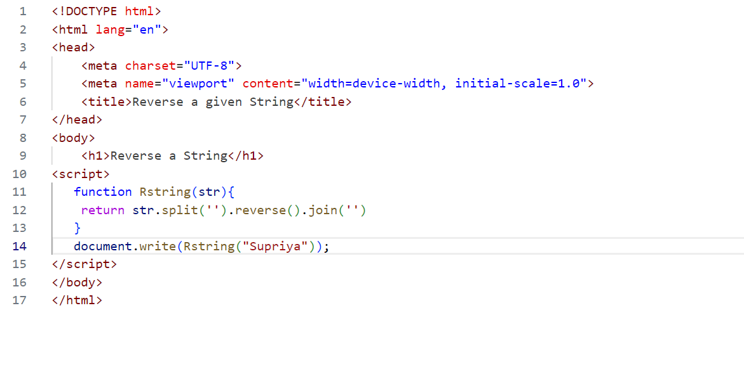

**Output:**

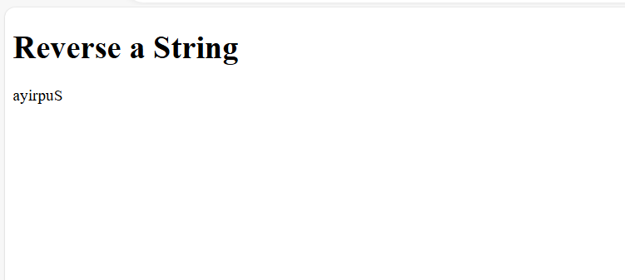

1. Write a JavaScript function that checks if a given string is a palindrome.

**Program:**

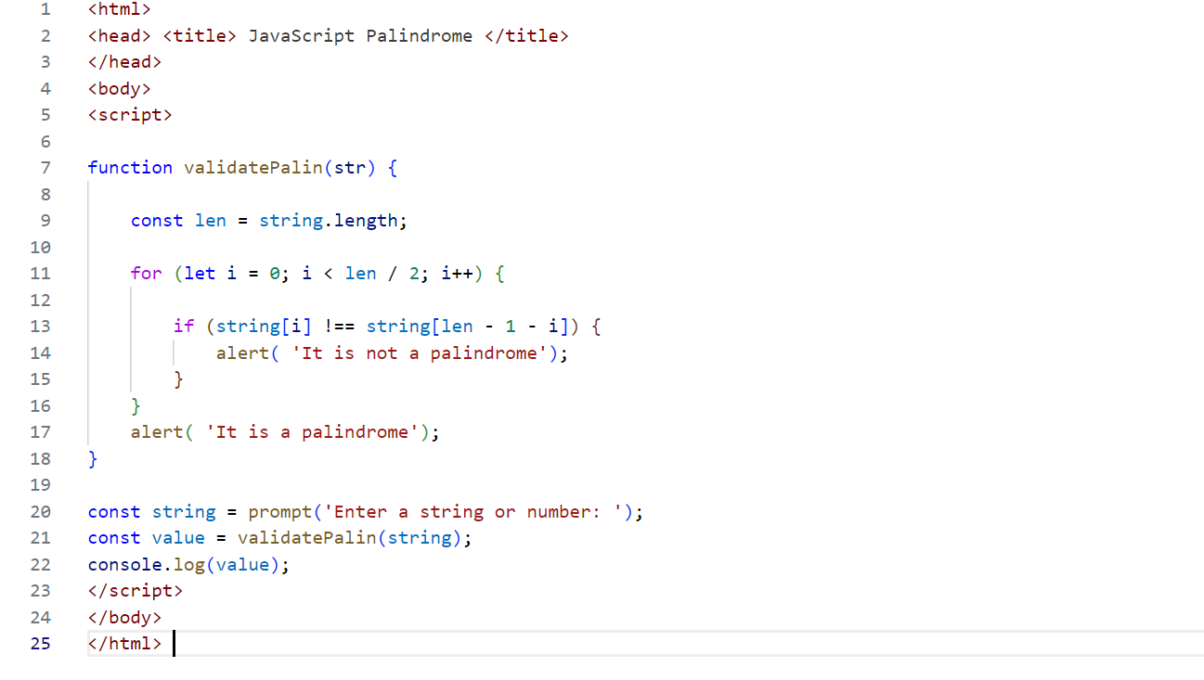

**Output:**

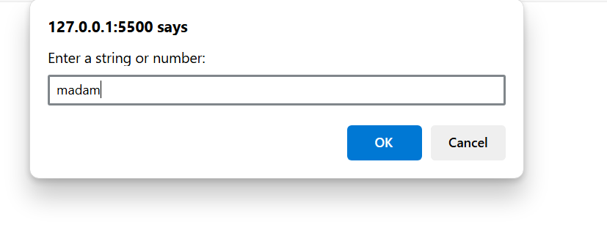

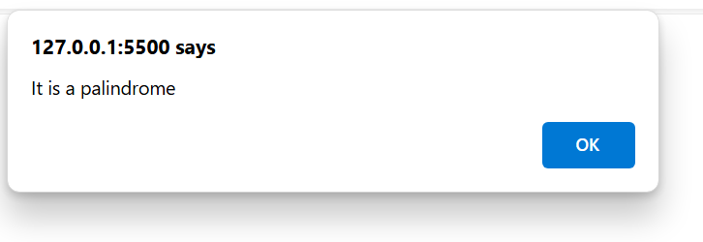

1. Implement a JavaScript program to find the sum of all elements in an array.

**Program:**

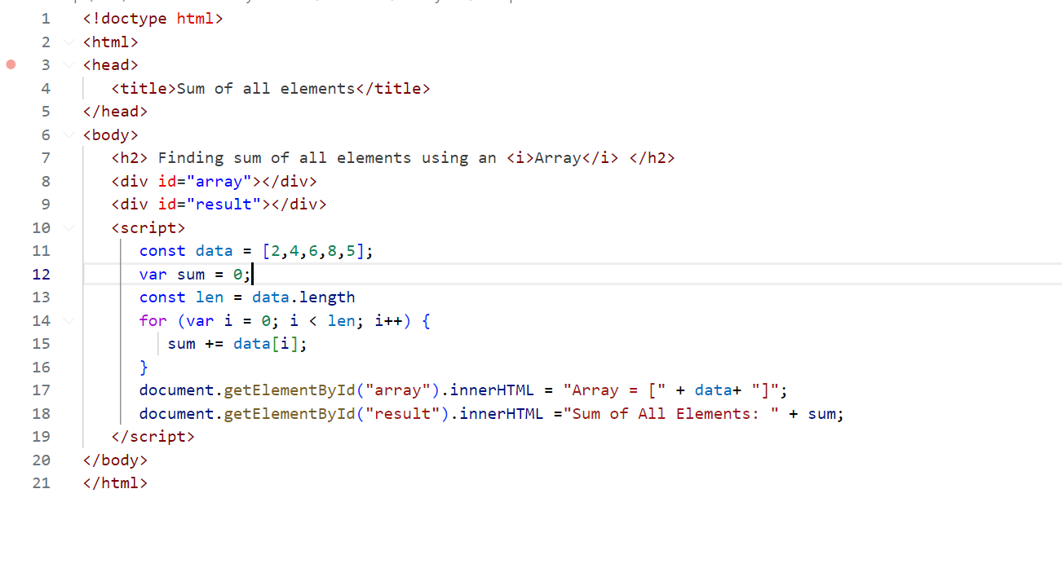

**Output:**

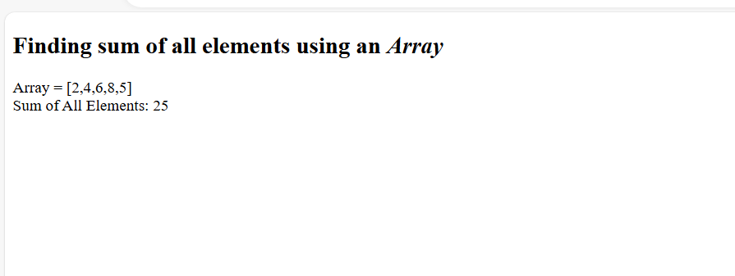

1. Write a JavaScript function to remove duplicates from an array.

**Program:**

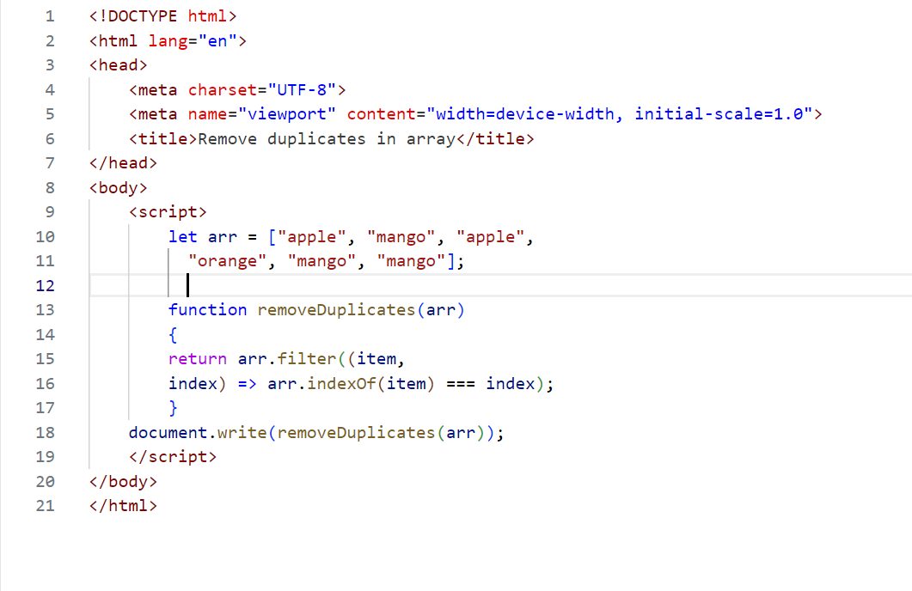

**Output:**

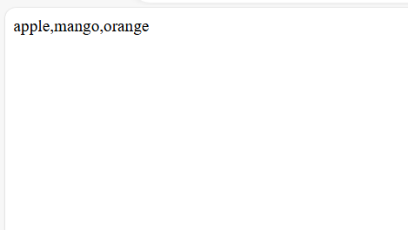

1. Develop a JavaScript program to find the second largest number in an array.

**Program:**

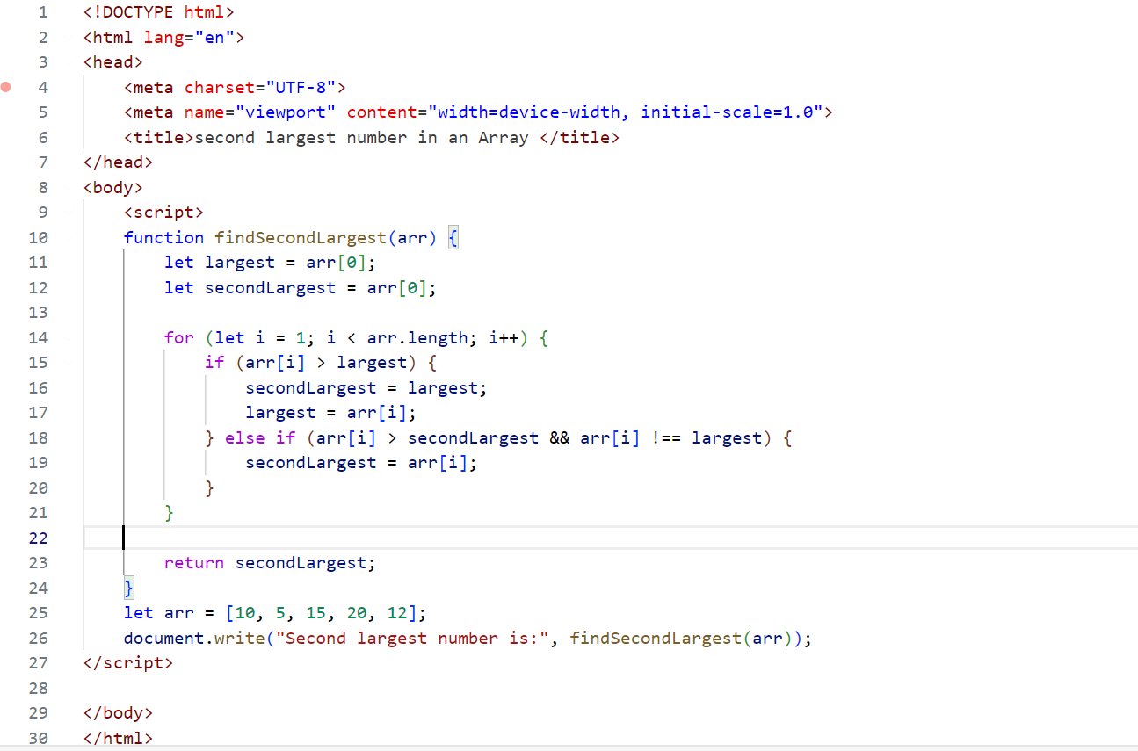

**Output:**

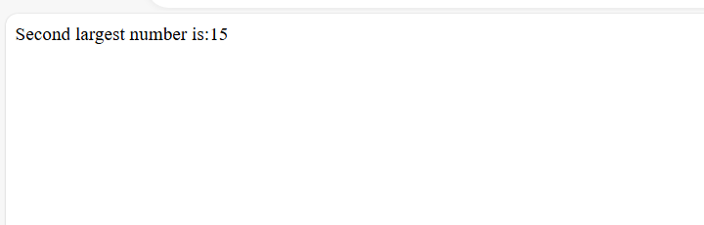

1. Create a JavaScript function that checks if a number is even or odd.

**Program:**

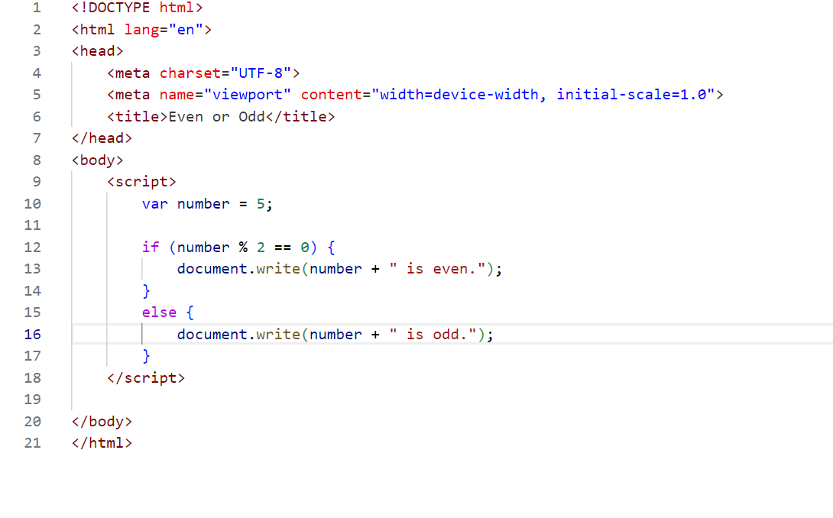

**Output:**

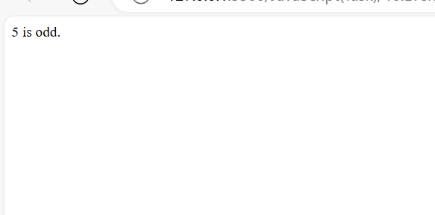

1. Write a JavaScript program to merge two arrays and remove duplicates.

**Program:**

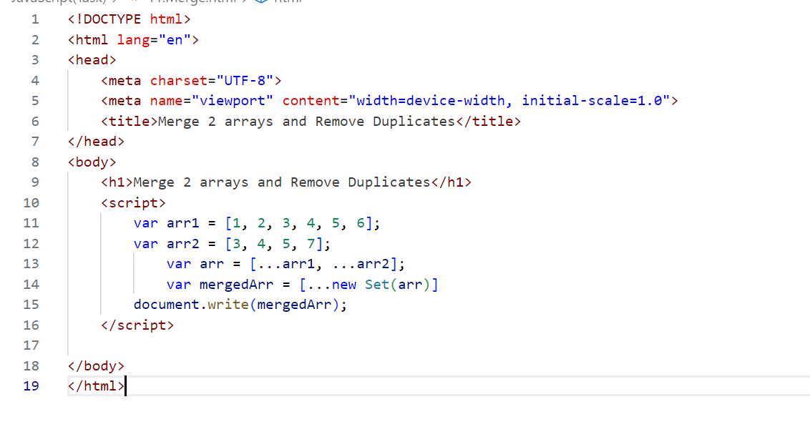

**Output:**

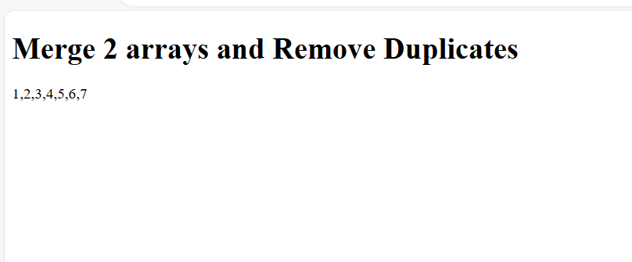

1. Create a JavaScript function to find the GCD of two numbers using a while loop.

**Program:**

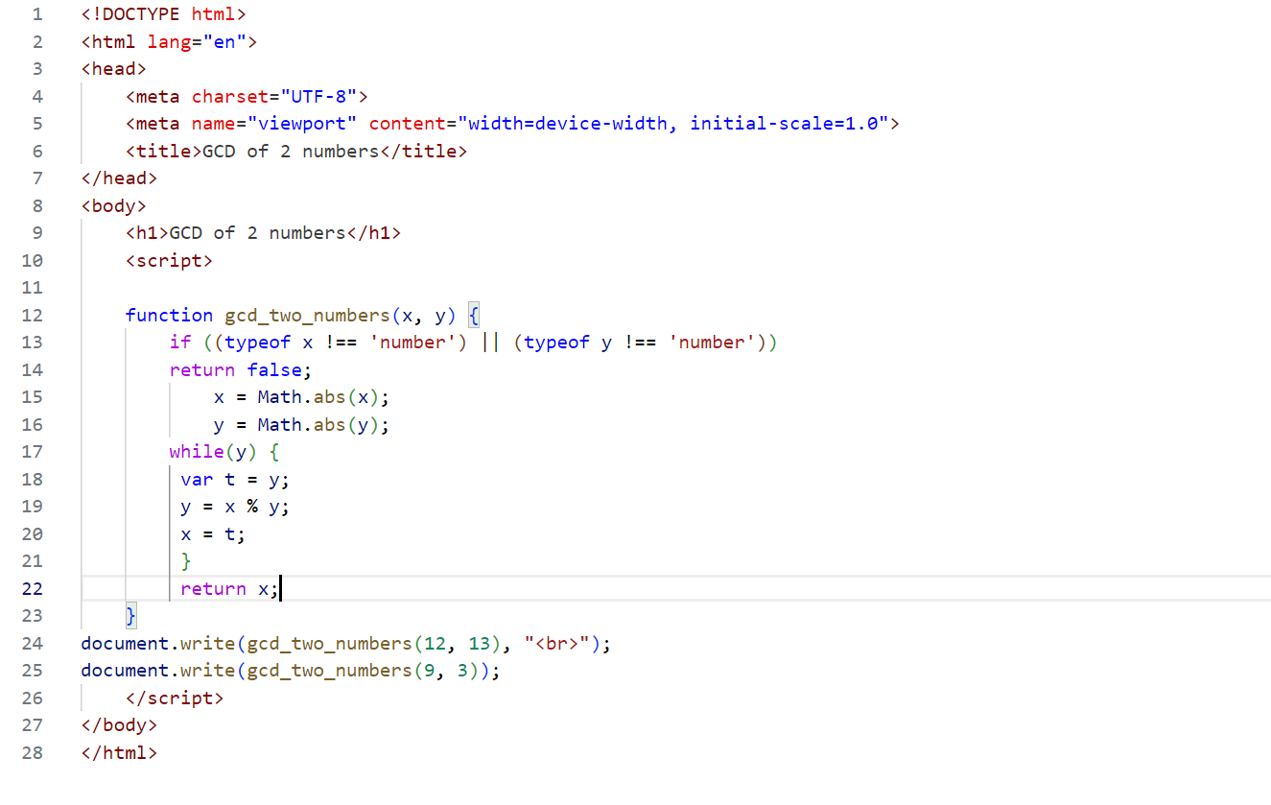

**Output:**

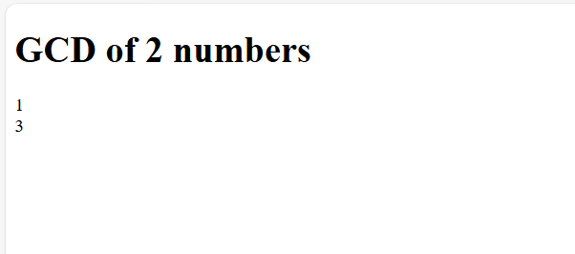

1. Write a JavaScript program to print the Fibonacci series up to a given number.

**Program:**

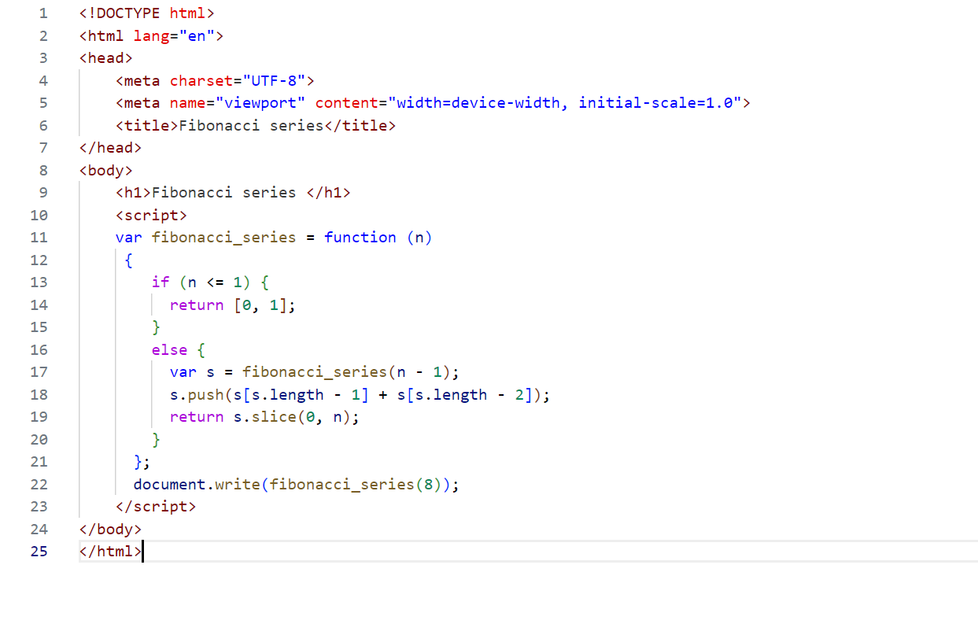

**Output:**

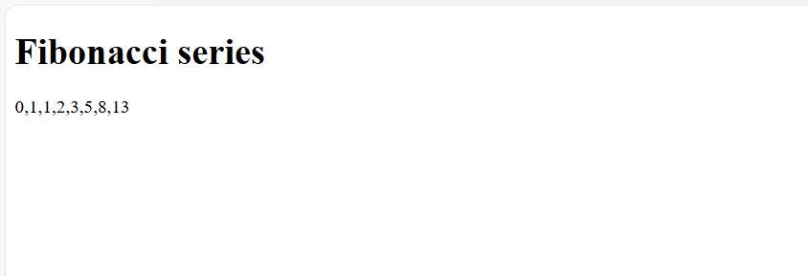

1. Develop a JavaScript function to sort an array of numbers in ascending order.

**Program:**

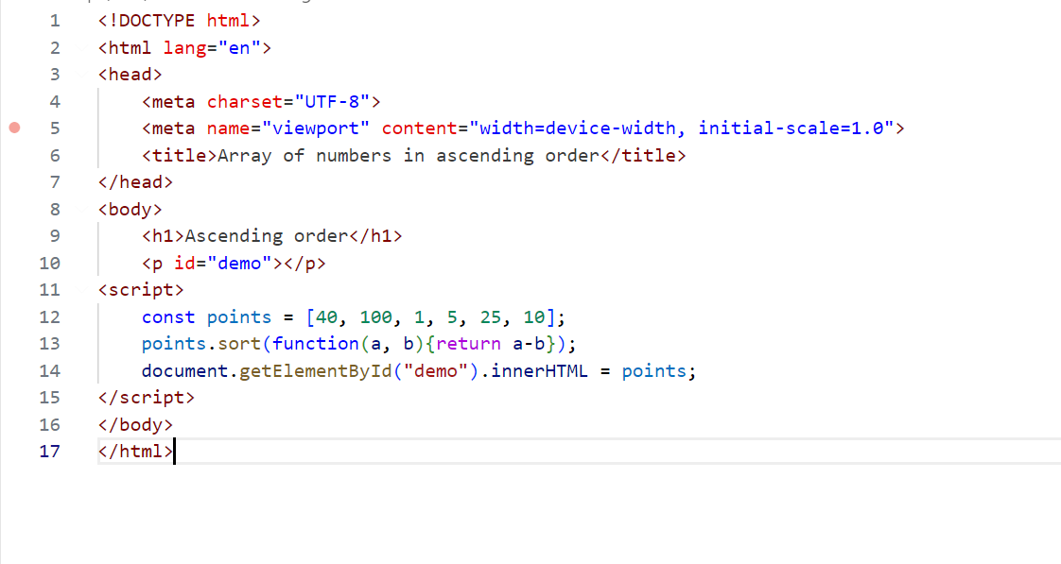

**Output:**

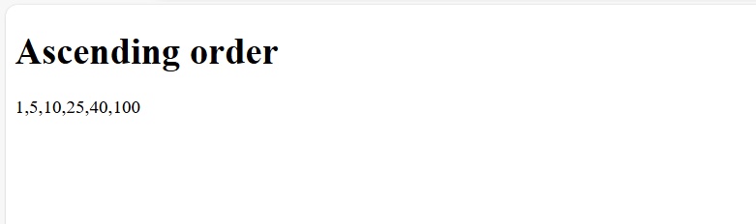

1. Write a JavaScript program to count the number of vowels in a given string

**Program:**

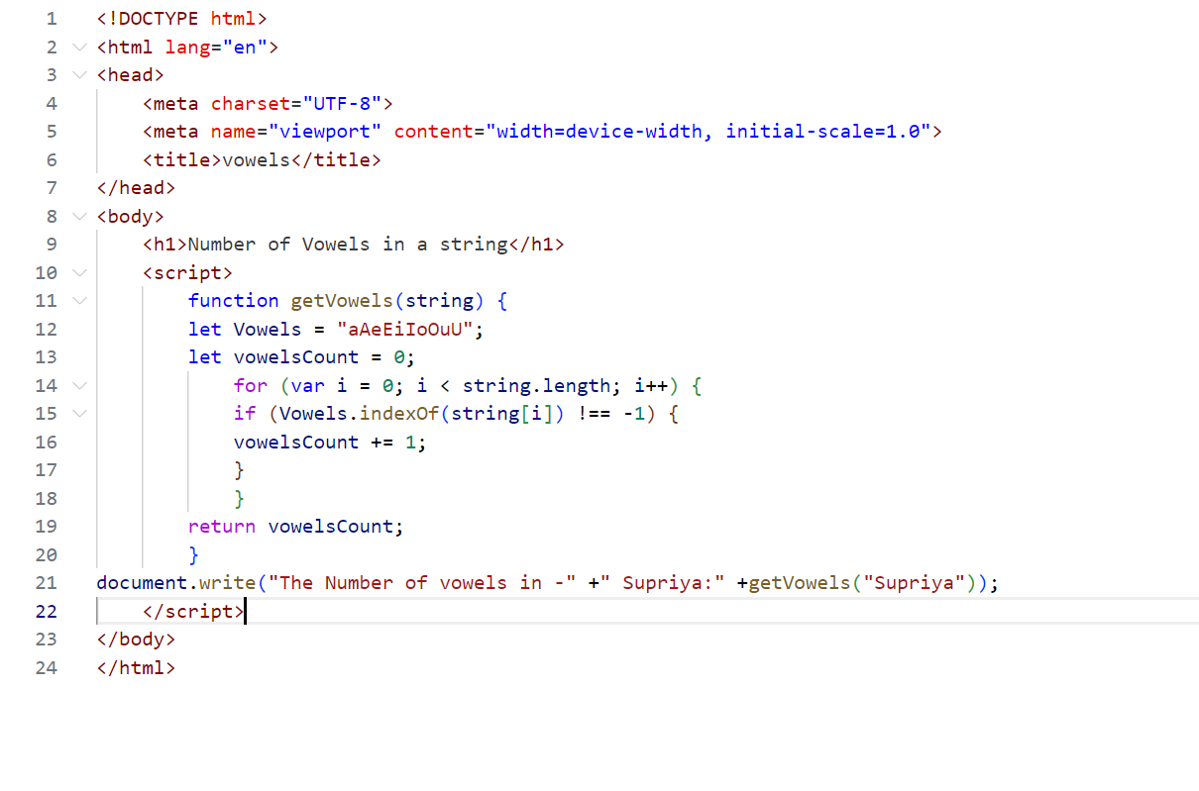

**Output:**

